Name: Dharmik Godalka

Roll No: 92400133054

Class: 4EK1

Academic year 24-25

Subject: Probability and Statistics (01CT1401) G1- A- Tutorial 2 as a part of Term work assessment
Problem Statement:
The Student News Service at Marwadi University (MU) has decided to gather data about the undergraduate students that attend MU. MU creates and distributes a survey of 14 questions and receives responses from 62 undergraduates (stored in the Survey data set).
  - For this data, construct the following contingency tables (Keep Gender as row variable)
I am just checking dataset that are this is working or not…
(I am creating this with using python…)
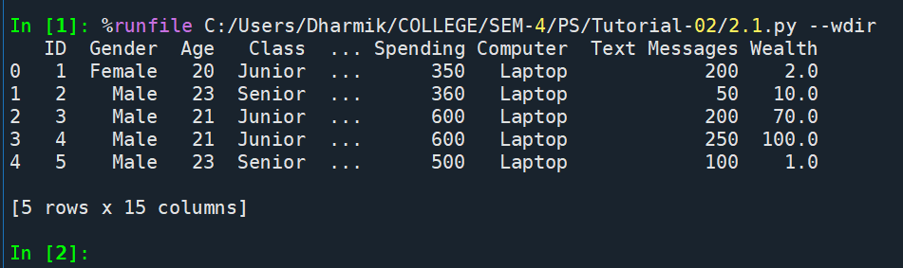
    - Gender and Major
Code:
import pandas as pd

# Load file for checking:
df = pd.read_excel("Tutorial 2 G1 A batch_MU_Students.xlsx")

table1 = pd.crosstab(df['Gender'], df['Major'])
print(table1)
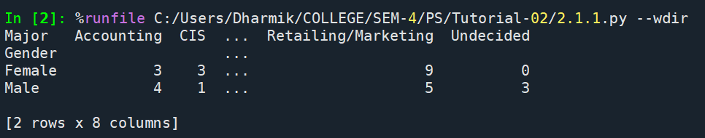
    - Gender and Grad Intention
Code:
import pandas as pd

# Load file for checking:
df = pd.read_excel("Tutorial 2 G1 A batch_MU_Students.xlsx")

table2 = pd.crosstab(df['Gender'], df['Grad Intention'])
print(table2)
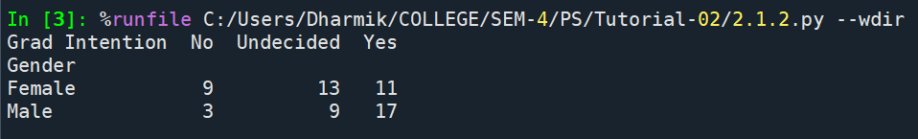
    - Gender and Employment
Code:
import pandas as pd

# Load file for checking:
df = pd.read_excel("Tutorial 2 G1 A batch_MU_Students.xlsx")

table3 = pd.crosstab(df['Gender'], df['Employment'])
print(table3)

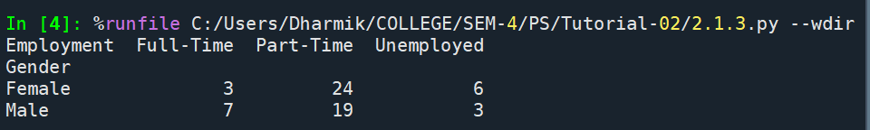
    - Gender and Computer
Code:
import pandas as pd

# Load file for checking:
df = pd.read_excel("Tutorial 2 G1 A batch_MU_Students.xlsx")

table4 = pd.crosstab(df['Gender'], df['Computer'])
print(table4)
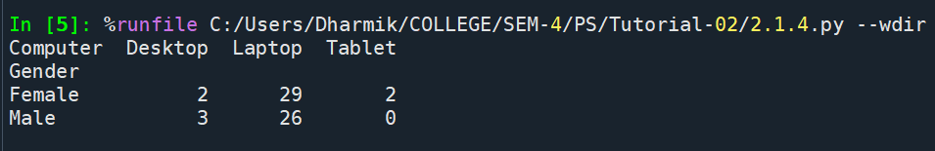
  - Assume that the sample is representative of the population of MU. Based on the data, answer the following question:
    - What is the probability that a randomly selected MU student will be male?
    - What is the probability that a randomly selected MU student will be female?
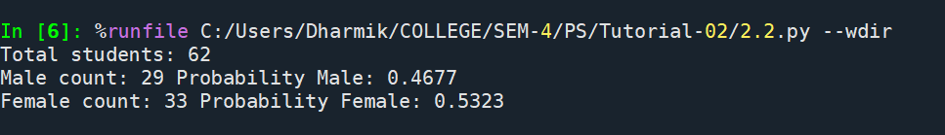
  - Assume that the sample is representative of the population of MU. Based on the data, answer the following question:
    - Find the conditional probability of different majors among the male students in MU.
2.3.2 Find the conditional probability of different majors among the female students of MU.
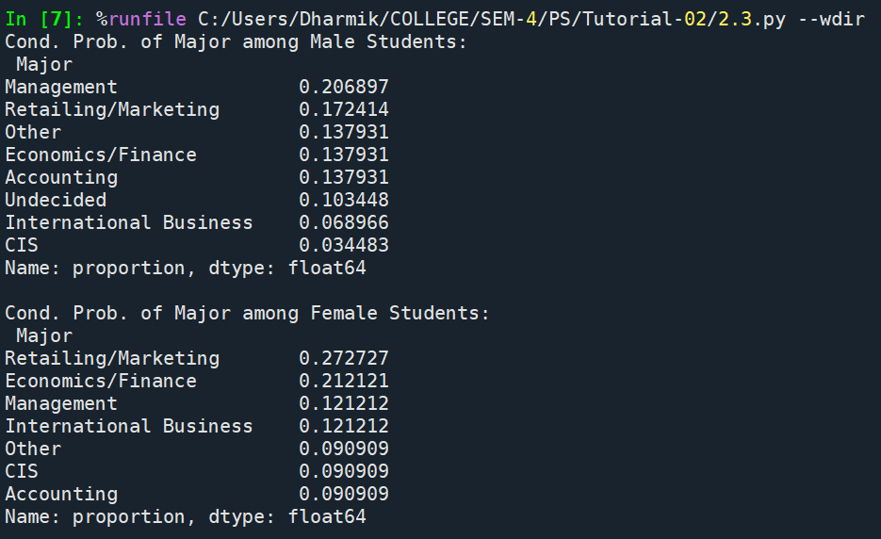

  - Assume that the sample is a representative of the population of MU. Based on the data, answer the following question:
    - Find the probability That a randomly chosen student is a male and intends to graduate.

Code:
import pandas as pd

df = pd.read_excel("Tutorial 2 G1 A batch_MU_Students.xlsx")

# male and intends to graduate:
male_g_count = ((df['Gender'] == 'Male') & (df['Grad Intention'] == 'Yes')).sum()
total = len(df)

prob_male = male_g_count / total

print("Male & intends to graduate count:", male_g_count)
print("Prob.:", round(prob_male, 4))

Output:
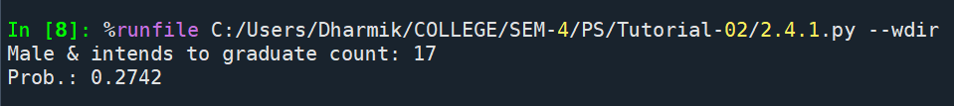

2.4.2 Find the probability that a randomly selected student is a female and does NOT have a laptop.
Code:
import pandas as pd

df = pd.read_excel("Tutorial 2 G1 A batch_MU_Students.xlsx")

# female and does not have a laptop
female_count = ((df['Gender'] == 'Female') & (df['Computer'] != 'Laptop')).sum()
total = len(df)

prob = female_count / total

print("Female & no laptop count:", female_count)
print("Prob.:", round(prob, 4))

Output:
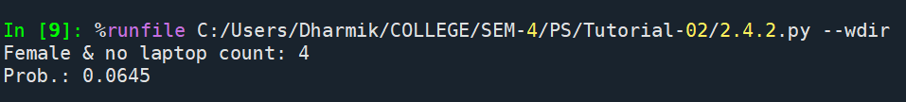
  - Assume that the sample is representative of the population of MU. Based on the data, answer the following question:
    - Find the probability that a randomly chosen student is either a male or has full-time employment?
Code:
import pandas as pd

df = pd.read_excel("Tutorial 2 G1 A batch_MU_Students.xlsx")

total = len(df)

# count:
male_count = (df['Gender'] == 'Male').sum()
fulltime_count = (df['Employment'] == 'Full-Time').sum()
male_fulltime_count = ((df['Gender'] == 'Male') & (df['Employment'] == 'Full-Time')).sum()

# prob.
prob = (male_count + fulltime_count - male_fulltime_count) / total

print("male count:", male_count)
print("full-time count:", fulltime_count)
print("male & full-time count:", male_fulltime_count)
print("prob.:", round(prob, 4))

Output:
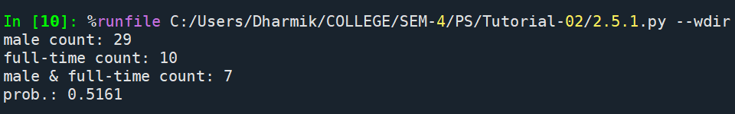
    - Find the conditional probability that given a female student is randomly chosen, she is majoring in international business or management.
Code:
import pandas as pd

df = pd.read_excel("Tutorial 2 G1 A batch_MU_Students.xlsx")

total = len(df)

female_df = df[df['Gender'] == 'Female']
total = len(female_df)

female_ib_count = ((female_df['Major'] == 'International Business') |
(female_df['Major'] == 'Management')).sum()

conditional = female_ib_count / total

print("female total:", total)
print("female in IB or manag.:", female_ib_count)
print("Cond. prob.:", round(conditional, 4))
Output:
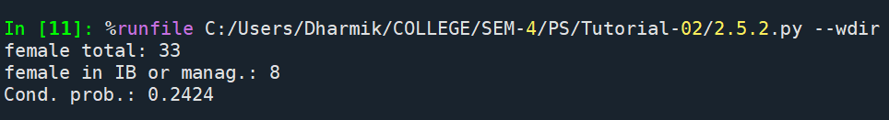

  - Construct a contingency table of Gender and Intent to Graduate at 2 levels (Yes/No). The Undecided students are not considered now and the table is a 2x2 table. Do you think the graduate intention and being female are independent events?
Code:
import pandas as pd

df = pd.read_excel("Tutorial 2 G1 A batch_MU_Students.xlsx")

# filtering undecided
grad = df[df['Grad Intention'].isin(['Yes','No'])]

# contingency table:
table_grad = pd.crosstab(grad['Gender'], grad['Grad Intention'])
print(table_grad)

# independence check
total = len(grad)
prob_female = (grad['Gender'] == 'Female').sum() / total
prob_yes = (grad['Grad Intention'] == 'Yes').sum() / total
female_and_yes = ((grad['Gender'] == 'Female') & (grad['Grad Intention'] == 'Yes')).sum() / total

print("P(Female):", round(prob_female,4))
print("P(Yes):", round(prob_yes,4))
print("P(Female AND Yes):", round(female_and_yes,4))
print("P(Female)*P(Yes):", round(prob_female*prob_yes,4))
Output:
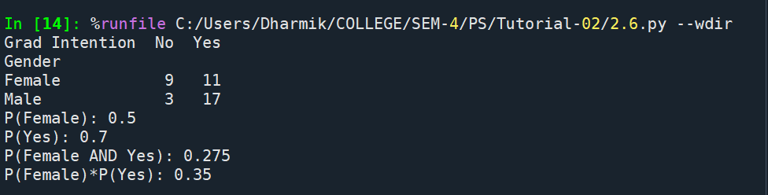

  - Note that there are four numerical (continuous) variables in the data set, GPA, Salary, Spending, and Text Messages.
Answer the following questions based on the data
    - If a student is chosen randomly, what is the probability that his/her GPA is less than 3?
Code:
import pandas as pd

df = pd.read_excel("Tutorial 2 G1 A batch_MU_Students.xlsx")

total = len(df)

# count GPA < 3:
gpa_count = (df['GPA'] < 3).sum()
prob = gpa_count / total

print("Students with GPA < 3:", gpa_count)
print("Prob. GPA < 3:", round(prob, 4))

Output:
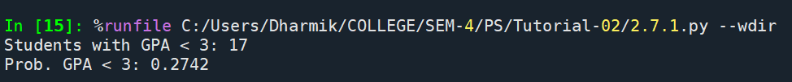
    - Find the conditional probability that a randomly selected male earns 50 or more. Find the conditional probability that a randomly selected female earns 50 or more.
Code:
import pandas as pd

df = pd.read_excel("Tutorial 2 G1 A batch_MU_Students.xlsx")

male = df[df['Gender'] == 'Male']
female = df[df['Gender'] == 'Female']

# male cond. prob:
male_salary_count = (male['Salary'] >= 50).sum()
prob1 = male_salary_count / len(male)

# Female cond. prob:
female_salary_count = (female['Salary'] >= 50).sum()
prob2 = female_salary_count / len(female)

print("Male Salary >= 50:", male_salary_count, "Probability:", round(prob1,4))
print("Female Salary >= 50:", female_salary_count, "Probability:", round(prob2,4))

Output:
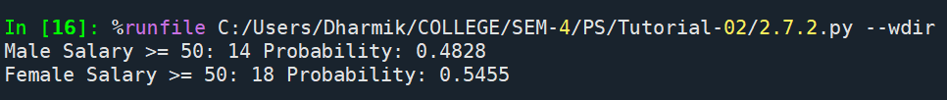
  - Note that there are four numerical (continuous) variables in the data set, GPA, Salary, Spending, and Text Messages. For each of them comment whether they follow a normal distribution. Write a note summarizing your conclusions.

Code:
import pandas as pd
import matplotlib.pyplot as plt

df = pd.read_excel("Tutorial 2 G1 A batch_MU_Students.xlsx")

for col in ['GPA','Salary','Spending','Text Messages']:
plt.figure(figsize=(12,5))

# histogram:
plt.subplot(1,2,1)
plt.hist(df[col], bins=10, edgecolor='black')
plt.title(f'Histogram of {col}')

plt.show()

Output:
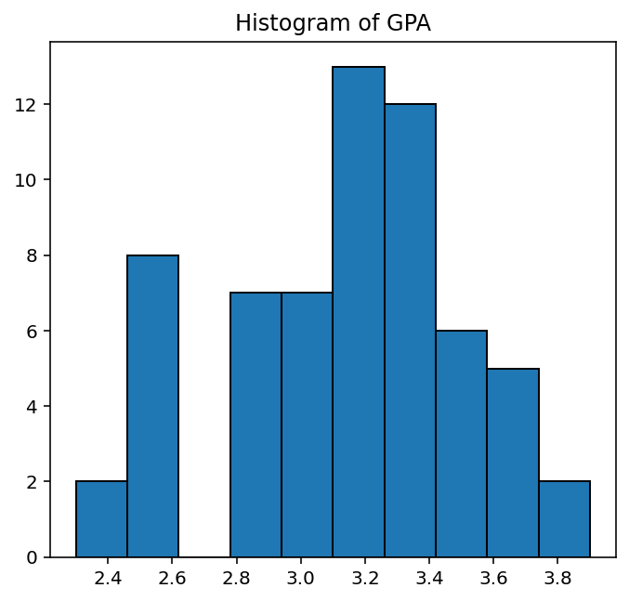

Conclusion:
The GPA histogram shows most students around 3.2, but the shape is not perfectly bell-shaped. This means GPA does not follow a normal distribution.

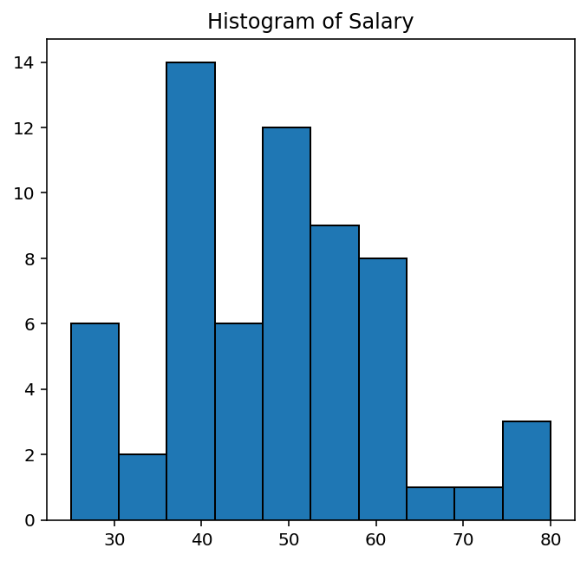

Conclusion:
The salary histogram is skewed to the right with many students earning lower amounts and only a few earning higher. This makes the distribution not normal.

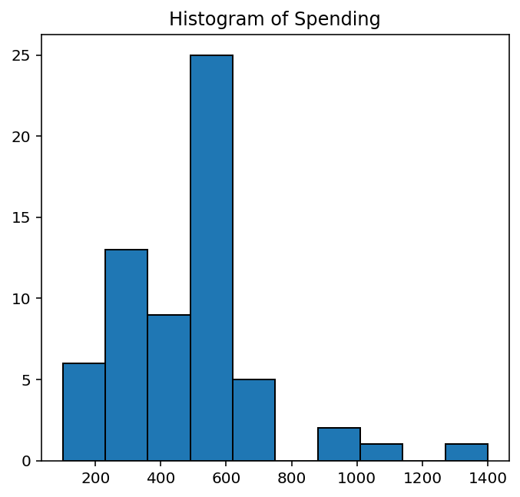

Conlcusion:

Spending values are spread unevenly, with no clear central peak. The histogram suggests that spending habits are not normally distributed.
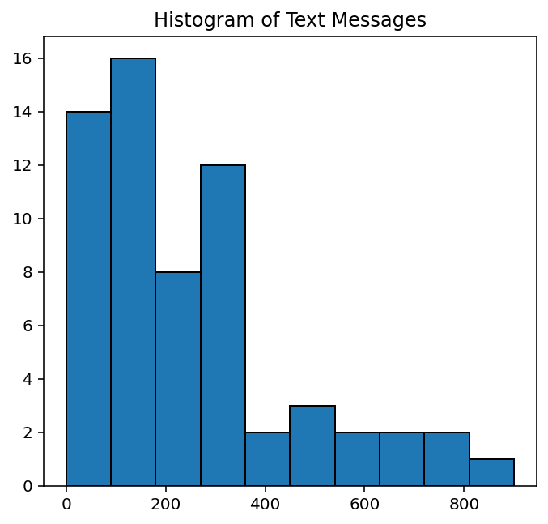

Conclusion:

Spending values are spread randomly with no clear central peak. The histogram suggests that spending habits are not normally distributed.

